[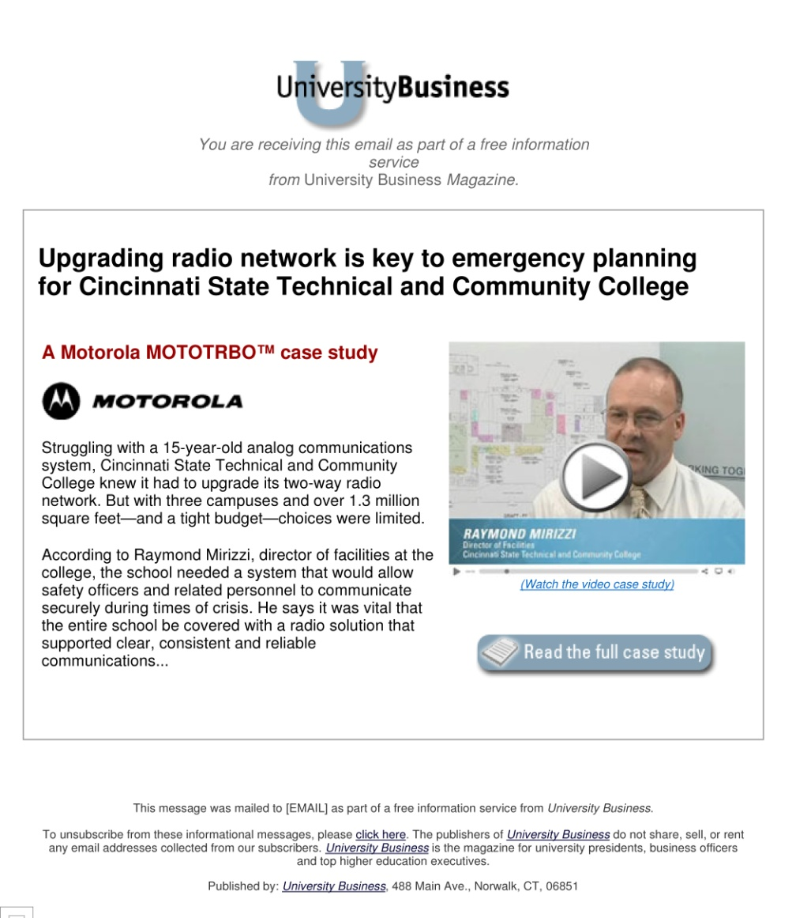](https://www2.gotomeeting.com/register/440577283)

***Wireless Just Found 6th Gear:***

*50% Faster Is 100% Better*

**VIEW WEBINAR NOW**

Your students rely on wireless devices for all their activities, from school work, to keeping up with friends and family. They expect connectivity, and your campus wireless network must provide enough bandwidth to keep your students productive and connected.

It’s time to for your school to refresh your infrastructure because **wireless just found 6th gear!** GovConnection invites you to **view this free webinar** that showcases new solutions to deliver high-bandwidth applications to your students—such as voice and video—over your wireless networks, while increasing performance and range.

We’ll also discuss the benefits of our [**Wireless Site Surveys**](http://www.govconnection.com/IPA/PM/Brands/ServiceConnection/Assessments/PCCGOV/~/link.aspx?_id=1F18F6712D5545CC9F57086AD73B996B&_z=z), designed to help you plan an efficient wireless solution for your campus, whether planning a new wireless network, or upgrading an existing solution.

**It’s Time to Move Forward with Mobility**

**Webinar: LINK PENDING**

*We will supply an “instant-view” link that we’ll create and post after the live event on August 30th*

**Wireless Site Survey:** <http://www.govconnection.com/IPA/PM/Brands/ServiceConnection/Assessments/PCCGOV/~/link.aspx?_id=1F18F6712D5545CC9F57086AD73B996B&_z=z>