**Union Graduate College Achieves State of Independence   
with New ERP System**  
[Union Graduate College](http://www.campusmanagement.com/en-us/campaigns/Pages/UnionGraduateCollege.aspx) had been on the same student information system as its undergraduate school and running two systems at the same time, one for recruiting and admissions, another for student administration. Everything was double entry. Then the demand for their graduate programs spiked in response to the economy. The college needed a new system and fast.

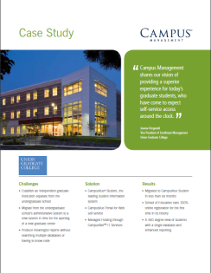**Union Graduate College Selects CampusVue Student**After a review of three leading vendors, UGC chose CampusVue Student hosted and managed by Campus Management. Six months later, the college had moved administration, student services, and academics across campus to a brand new graduate center supported by a brand new system.

**Challenges**

* Establish an independent graduate institution separate from the undergraduate school
* Implement a new administrative system in time for the opening of a new graduate center
* Produce meaningful reports without searching multiple databases or having to know code

**Solutions**

* CampusVue® Student, the leading student information system
* CampusVue Portal for Web self-service
* Managed Hosting through CampusNet IT Services

**Results**

* Migrated to CampusVue Student in less than six months
* School of Education sees 100% online registration for the first time in its history
* A 360 degree view of students with a single database and enhanced reporting

“It’s clear that Campus Management shares our vision of providing a superior experience for today’s graduate students, who have come to expect self-service access around the clock to virtually every aspect of the college.”

Joanne Fitzgerald I *Vice President of Enrollment Management* I Union Graduate College

http://universitybusiness.com/mailing/campus_mgmt/201010/click_here.jpg



**Email Links:**

1. Photo header
2. “Union Graduate College” hyperlink in 1st paragraph
3. “Read Case Study” button
4. “Click Here to Read the Case Study”

These 4 items should link to this address:   
http://www.campusmanagement.com/en-us/campaigns/Pages/UnionGraduateCollege.aspx